[](http://sjrlc.lib.overdrive.com/D8A57479-FF44-40AC-B19D-00A8706ACA6B/10/337/en/Default.htm)

**Borrow Free Bestsellers and Other Books Using Your iPad or iPod**

**Use the IMC’s Overdrive Catalog**

**http://wtps.org/Page/561**

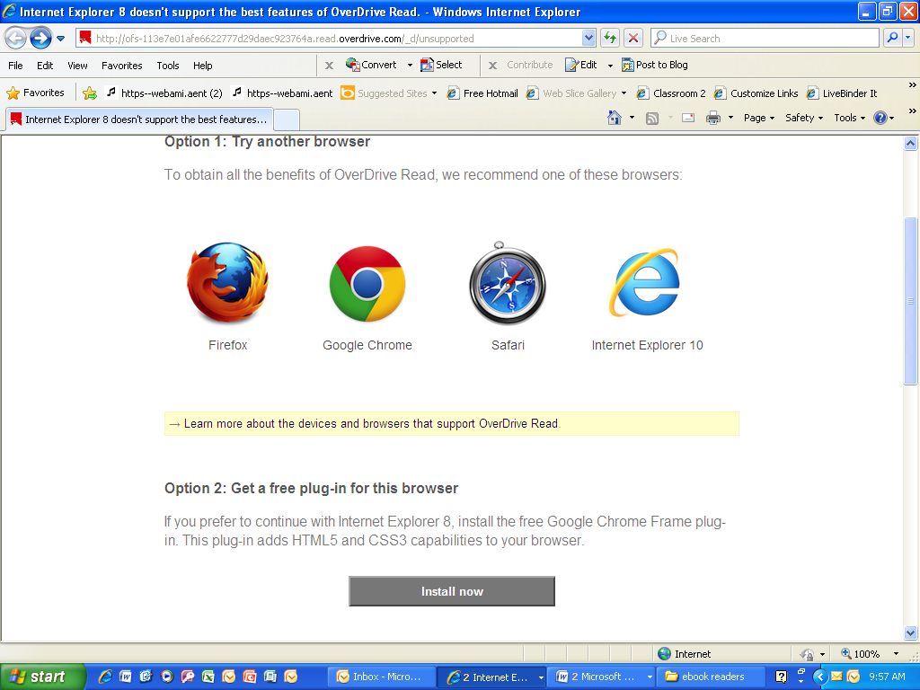**Overdrive prefers the following Browsers:**

**Using the Overdrive App**

**Instructions for Overdrive App from App Store**

1. Go the App Store and download the app to your IPhone or IPad
2. You will be asked for your Apple ID and password.
3. Get an account
4. 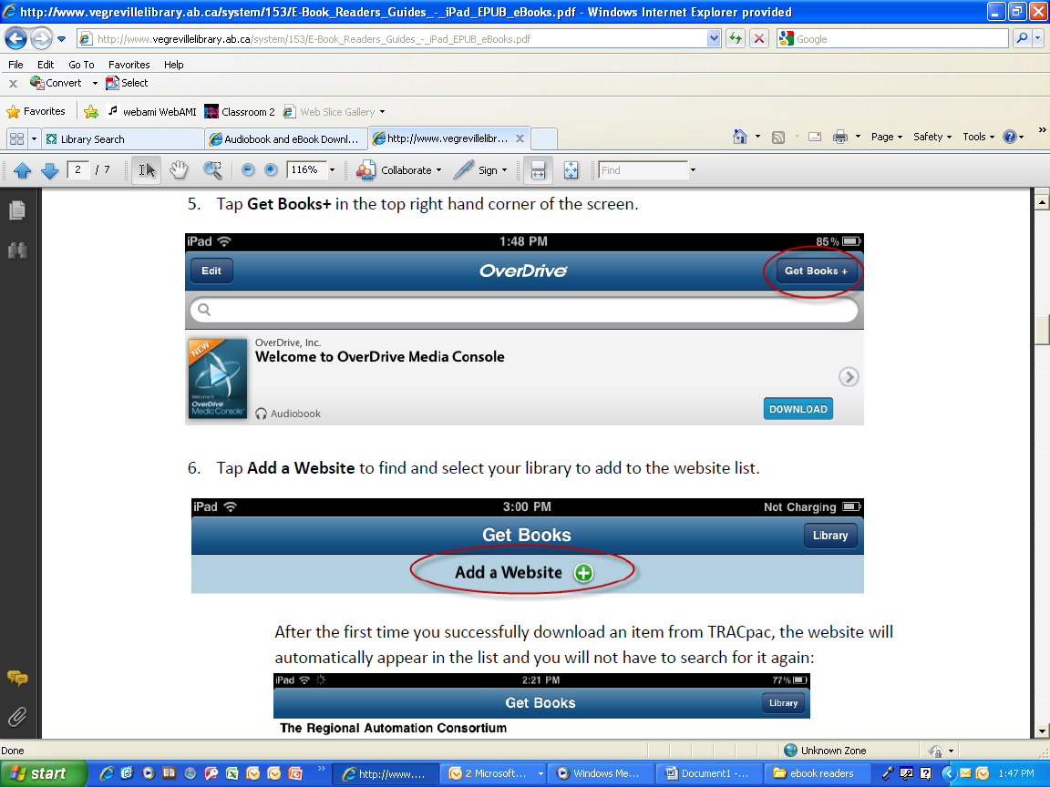Follow the prompts to create an OverDrive account.

Directions for Downloading or Reading on your IPad

1. Tap on the Overdrive icon Sign up for your account. Or Sign in
2. Tap on the Menu (top left 3 lines) and then Get Books
3. Tap on Website to add your library
   1. Search for South Jersey Regional Library Cooperative or Washington Township Public Schools.
4. Tap on the library (South Jersey Regional Library Consortium
5. Locate e books by searching or browsing. When you find your book, tap on the book. You will be asked to locate your library. Located Washington Township Public Schools
6. 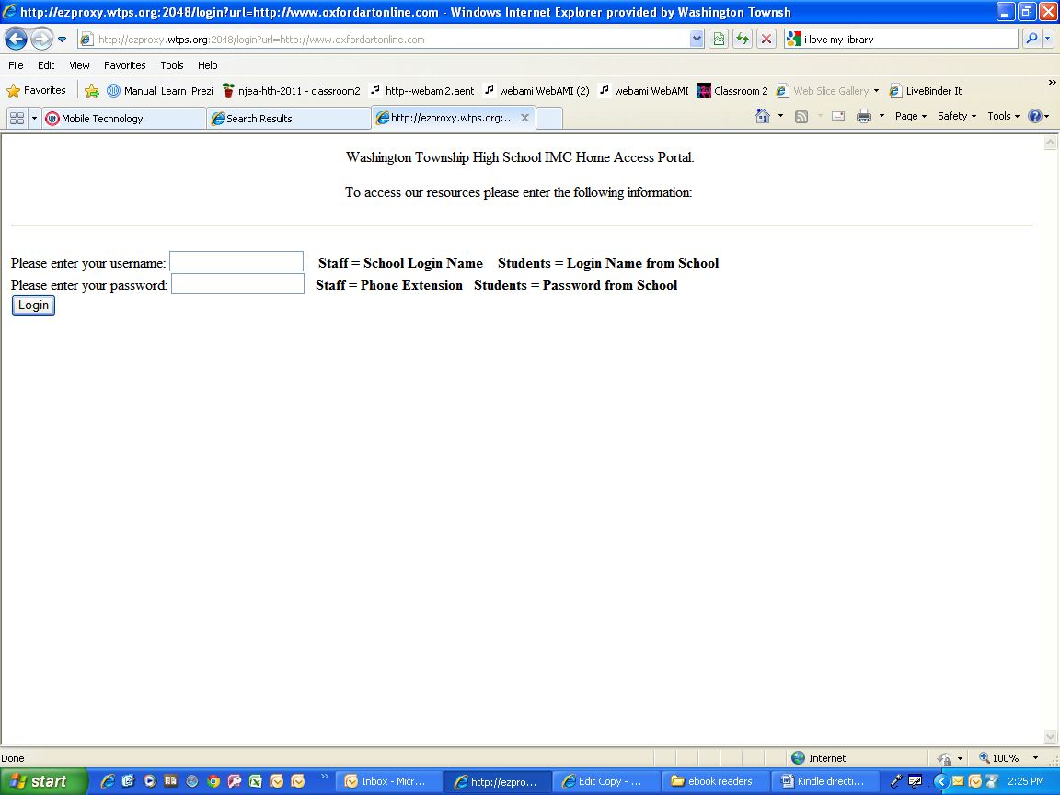**Enter your user name Teachers: your school login and your password is the number that you use in the copy machines Students: use your school login and password**
7. If the book is available, you can click on Borrow by tapping on the book cover **(if the book isn’t available, place a hold and when available, you will automatically receive it.**
8. **Select Read in Your Browser**
9. Tap on the book to begin reading.